Sensitive Species Case Studies
Case Study | Treatment(s)
Protection of people’s names, privacy considerations etc  - General and legislated privacy  - To shield people from possible reprisals by animal-rights activists  - Observational data can be interpreted to include (possibly illegal) collecting of material, while it usually consists of photographic records only.  - Often landholders don't want folks to know what is on their land or even that their land has been surveyed | Restrict privacy information  Obfuscate / withhold coordinates and withhold / generalise locality information
Let researchers know that the material / specimen exists as does the data. They can then make a special request if they need the data. This applies to State and Federally listed species in the US as well as species on the IUCN red list that are Critically Endangered, Endangered, or Vulnerable. | restrict all fields except taxonomic info and specimen accession number
For certain types of sensitive data, we do not display any locality information lower than county level (including geocoordinates, elevation, precise locality) | Replace locality information with county / district  Replace provided lat longs with lat longs of the county / district centroid  Replace elevation with elevation of county centroid?  (this could be equivalent to state/Territory or LGA in Aust)
Some datasets are served with locality data finer than county redacted either for particular records or for all records - redaction of some records is usually based on name lists of threatened and endangered species. Redaction may involve the addition to the publicly accessible records of comments in square brackets or may simply be silent removal of data. Latitudes and Longitudes may be truncated (with notations or silently) | Withhold locality information  obfuscate coordinates
grids or polygons instead of points, not always because of sensitivity, but because of uncertainties on the exact location. | Grid data rather than provide point coordinates
We also blur the locality information from any images of sensitive specimens we make available online | Obfuscate/ blur locality information on specimen images – do we need a DWC field to say that the associated image has been withheld or obfuscated
Site names that reveal the exact location of a sensitive species. | Alter site names, withhold locality information, or site names (withhold attributes)
Locality for some records where the fossils needs to be protected from fossil dealers. | Withhold locality / Withhold coordinates
Sensitive species data not shown. Message is to contact curator for further information and access is given to legitimate concerns. | Withhold all records of sensitive species
Habitat information – associations with key habitat types or species or foraging species or feed species could inadvertently disclose sensitive species locations e.g:  - Habitat type often also needs to be redacted (i.e., it's pretty easy to work out where the one bog on Kauai is)  - Butterfly group submit data from coastal dunes containing a sensitive species butterfly and suitable foraging plants. They are concerned about the butterfly being taken for private collections and perceive this to be a significant risk (2.1) . They are also concerned that the presence of the known foraging plant will expose collection sites as well (2.1 for associated plant species - perhaps needed in a certain region of the state only)  - Fungi researcher submits data but asks that any records of the toxic 'deathcap' are denatured in a way that makes it difficult for the public to find but allows its presence in an area to show up for researchers, land management and biosecurity staff. This triggers reason 2.2 (depending on whether the matrix determines 'death cap' as extreme, high or moderate) and treatment could be 2.1 (10km fuzz) or even 1.2 (embargo records) if the species was having an abundant season and suitable habitat within a 10km area may be clue enough to find the fungi.  - Site description attributes such as cave names; stratigraphic unit/formation names ability to inadvertently disclose fossil locations | Withhold habitat information / habitat type. Obfuscate coordinates? Withhold Site ID / information. withhold or obfuscate records of associated taxa (need to consider where these have been collected as part of a survey as well, as part of a collection or by the same collector)
Collector’s / observer’s / Determiner’s names - Restricted for a number of reasons – privacy of living people; could be used to track itinerary, etc.; some countries have privacy legislation.  - Collector names often need to be redacted - they've had concerns with being targeted by some groups (think cat colonies) | Withhold attributes
We can't share data the contributors don't want to share, period, because not sharing them for a limited amount of time (up to two years) is a condition for them contributing the data. This is long-held and widely known organizational policy (e.g. iNat use case?) | Withhold data from a particular data collector / contributor / dataset
- We have experienced situations where canny users have found records by the same collector with an adjacent collector's number or date, but of a non-conservation taxon, and extrapolated the collecting locality given to apply to a collection of a conservation taxon. The only way to avoid this would be either to generalise all records, or obscure collectors’ number and date along with geocode. This would leave sheet number as the only unique key reference for each record but restrict it to a single institution. (Ie. finding all the institutions holding replicates of 'Bloggs 1234' would not be available.) I am also aware of data mining of other Australian herbaria's contributions to GBIF, where that herbarium has not known or flagged the record as a conservation taxon, and so detailed locality statements for a WA endemic conservation taxon have been freely available via the GBIF portal.  - Osprey nests along a prime coastal stretch are impacting development approvals. Release of the nesting data is considered high risk in case it attracts unwanted interference effecting survivorship of young. Fuzzing data has limited impact as the nests stand out along linear coastal stretch and the birds are visible and often the nest locations well known in public circles. Obfuscating the date to year may make targeted interference during nesting harder (3.1). The same situation but for a species like seals which do not have an annual breeding cycle may need decade obfuscation (3.2). If this is still not adequate withholding data may be required (treatment 1.1 or 1.2) – but comes at the risk of the records not being discoverable to developers.  - The use of redacting based on dates is useful (i.e., a data embargo on tracking live organisms - think introduced species)  - iNaturalist generalizes date to month for sensitive observations (example https://www.inaturalist.org/observations/129813207). We could add an option of 3.1 (relabelling the others as 3.2 and 3.3): “Date generalised to Month” | Withhold collector names /numbers  Obscure collection date  Generalise coordinates of all records in a collection
Currently little data is publicly accessible, but we think it likely that we will not make detailed distributional data available for plants likely to be threatened by over-collection, and we will restrict traditional use information. | Obfuscate coordinates  Withhold locality information?  Withhold traditional use information
For viewing external to the Department, or for users with an insufficient privilege level for viewing our specimen data, we routinely exclude the detailed Locality statement and substitute 'Nearest named place'. If we provide a geocode in these circumstances, then it is 'generalised' to the nearest 10 minutes. (Actually, it is not necessarily the nearest 10 minutes, we simply lop off the last digit of the minutes field prior to delivery). | Generalise coordinates to whole minutes  Generalise Locality information to nearest named place
Replace with alternate wording for example, "This specimen represents an endangered or threatened species. The specific locality has been removed from the on-line record to protect this species from over-collection. These data may be supplied to researchers on request." | Withhold locality attributes
There is concern that the nest (or nest tree) may disappear prior to permit related surveys. We consider the following to be sensitive occurrences: bat hibernacula, bat day/night roosts in caves/mines, bat maternity roosts; locations of special status (=sensitive) invertebrates; raptor nest locations; federally listed Endangered and Threatened plants. In addition, if we know that a private landowner does not want information released about an occurrence (of any special status species) on his/her land, we regard that as sensitive and do not export it (in other words, we won't generalize the location but will simply exclude the occurrence from our GIS export  Sometimes obfuscation of point locality may not be enough in remote areas e.g. large lakes, land formations etc – easy to pinpoint where in the landscape the record is most likely to occur e.g. for fossils, cave dwelling or lacustrine species | Withhold records
Preclude deliberate sabotage or collection by unscrupulous and commercial collectors, poaching, hunting, disturbance, over exploitation, etc.  - Protect populations of ferns, orchids and cycads from plant collectors  - There is a history of egg thefts from falcon-nests and although digging up of rare plants has not been a problem until now in Iceland, we choose to mask the accurate coordinates of plants on red-lists.  - We are concentrating on succulent plants incl. cacti, and a majority of our holdings is of CITES-c overed taxa, so conservation is the primary reason to withhold data.  - Many of Arizona's plant species (esp. cacti) have value on the market, are located on wide open public lands, and illegitimate collecting is easy.  - Commercial and illegal fishing | Withhold data  “Mask” coordinates -Obfuscate, withhold, grid, centroid of region etc.
Allow for publication of research results.  - To prevent stealing of unpublished data  - Data are a “resource”. The most immediate way of getting benefit from them (after having spent energy in data-gathering) is publication. This is an effective pressure, since the researchers are evaluated for publishing results in scientific journals, not for making the data available to others. Thus a “quarantine” period to analyse the data first, then (second) make the available to others is by now the pattern that might enhance “survival.” | Embargo data for defined period prior to publication
Biosecurity, Quarantine, and trade considerations  - Sensitive data being quarantine inception data – if released this would have market access and biosecurity consequences.  - We would be overly concerned about making data from quarantine interceptions publicly available because it could create an international trade incident if our collection were to tell the world about the presence of an exotic pest in Australia or a trading partner. These records are tagged. We also have some highly desirable and protect records of jewel beetles and we would not like the exact location of these to be public. (not tagged)  - Some quarantine records not publicly available | Withhold records / datasets?
Benefit sharing – need to maintain good relations with countries of origin etc.  - The main reason to limit access to monitoring data (phenotype) is competitive advantage in the development of new food crops.  - Highly desirable fossil species such as Megalodon and other sharks, Horodyskia, stromatolites, ammonites | Withhold data for economically important species / research?
Data used to derive income: Images are the main category here, these include rotifers, which due to conflict with CD sold as publication are only served at low resolution over the web | Decrease resolution of images

OTHER CONSIDERATIONS
Fear the user may make inappropriate use of the data: not knowing purpose to which data will be put; fear of misinterpretation.  - Data incomplete or fragmentary or representative of only partial population distributions or relative protection on conservation estate. Occasionally it is incompletely identified, misidentified, or not provided with the most recent applicable name. Without adequate knowledge and usually discussion of the project for which the data is sought cannot guarantee that it is fit for purpose. | Discussion with data requestor prior to release to ensure fitness for use of data for the requested purpose – improve metadata
Protection of IP rights, including need for proper attribution and citation | Legal agreement to ensure proper citation and attribution of products using or derived from data
If the selection of a sub-category is necessary, one worry here is that not all data custodians gradate data restrictions by species or threat level (extreme, high, moderate). Reptile and amphibian databases in North America (e.g., HerpMapper, H.E.R.P., Michigan Herp Atlas) often generalize all species locations to county or state given that common species locations may allow for inferences about rare species, and prevalent species are also targeted for the pet trade or personal collections. Some species may be at a greater risk of exploitation than others, but the databases don't always assess species individually or account for different threat levels in treatments. HerpMapper makes some exceptions in generalizing to state rather than county for certain higher risk species. But in cases where data custodians don't assess species individually, they would need to select one category from 2.1-2.3, which may not accurately capture differences in the risk of exploitation at the species level. Some non-helping databases (e.g., TreeSnap) also generalize all species locations to mitigate exploitation, without accounting for differences in threats across species.
Other databases import conservation lists, e.g., IUCN Red List, and treat all species with certain conservation statuses as sensitive. Pl@ntNet does this as an example. Here too, they're not assessing species individually, so if they had to select a single code from 2.1-2.3, it would not capture differences in the true degree of risk facing species.
Do the sensitivity reason numbers align with the treatment numbers ?. If not perhaps make them very different (ie alpha instead of numerical) so they are not confused/linked. If they are aligned then does that mean that reason 2.2 -high risk, aligns with treatment 2.2- 1km fuzzing - which is typically not considered enough in most states for high risk species

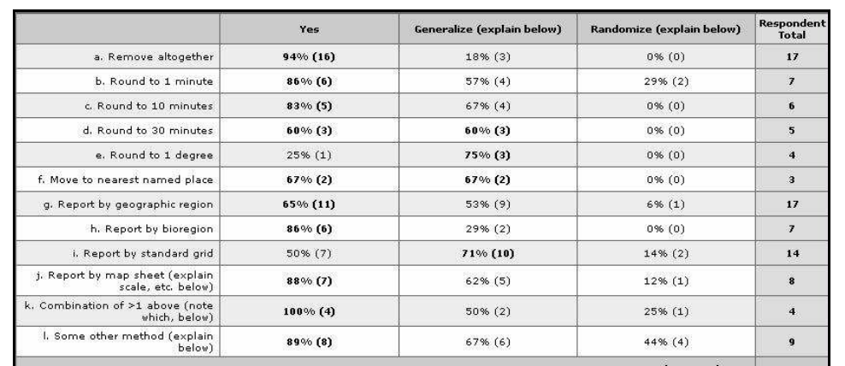
Treatment use cases (from Chapman)

